**Keep America Beautiful**



**Cougar Student Technologies**

**Alex Garcia, Arianna Camino, James Hanlon, Oscar Castellanos, Vinny Vue**

**Table of Contents**

**Executive Summary 3**

**Application Development** **4**

Business Context 4

Project Proposal 4

Requirements Matrix 6

**Project Management** **7**

Gantt Chart 7

Cost Tracking Chart 9

**Team Information** **10**

Team Resumes 12

## 



**Date** : 2/29/2021

**To** : Dr. Wesley Schultz

**Cc** : Dr. Shaun-Inn Wu, Director of Projects

**From**: Oscar Castellanos, Cougar Student Technologies Team

**RE**  :Phase #2

**OVERVIEW**

Dr. Wesley Schultz,

In phase 2 of the project, we have gathered and finalized any last requirements from our JAD2 meeting and we will now begin designing our solution.

**NEXT PHASE:**

For the next phase of the project, we are going to create a use case diagram, an activity diagram, an ER diagram, and a functioning prototype. The estimated cost of the next phase will approximate $2,650.

**TIME AND COST:**

The time and cost of the second phase between a team of five CST members has totaled 38 hours at a rate of $25.00/hour, yielding a total amount of $950. The remaining three phases will be projected to cost $6,475. The total cost of the project approximates to $9,075 and is subject to change as we continue working on the project.

Enclosed: Report #2

___________________________________ __________

Customer Acceptance Print & Signature Date

### 

### 

### 

### **Application Development**

#### **Business Context**

Keep America Beautiful is a non-profit organization that aims to end littering, improve recycling and beautify communities through various programs and initiatives. The organization is supported by community-based affiliates, volunteers, corporate partners, municipalities, and elected officials. Previous partners have worked with Google Street View Static API for pulling Google Street Images using python scripts.

**Business Problem**

Keep America Beautiful is seeking for a solution to obtain images from Google Street View to be processed by an algorithm that identifies litter. They also require the solution to be automated to allow for larger scalability and efficiency.

#### **Project Proposal**

Our team will create a system for pulling these Google street images for a designated area given the city, region, community, county, etc. The objective is to design a program that will automate the process of obtaining images for detecting litter. So that once the system has been developed, we can then pass these images through the ML algorithm to get their litter scores.

**Deliverables**

* A program that will process coordinates to retrieve images of a given area.
* Any detailed attempts of third-party tools to automate this process. We are going to first begin with OSMNx as suggested from previous groups and report our attempts.
* We would like to retrieve latitude and longitude coordinates as well as the image itself.
* The client should expect to receive a word document report of the prototype in their email inbox.

**Measures of Success**

Phase 1:

* Identify project requirements and needs from client and report Meeting Minutes back to understand project workers know what to accomplish.

Phase 2:

* Finalize project requirements and needs from client. Meeting JAD 2 with the Client and Director to finalize questions, confusion, must haves and nice to haves.

Phase 3:

* Begin Prototype 1 with understanding of last year's projects and direction that can lead us into making an automated program to take 360-degree pictures of street view in a designated area. Wire frames and coding can start by leading us through one street at a time and capture images along that street.

Phase 4:

* Complete image capturing along a city/town or area radius defined by the user. Possibly save those images in a database and then possibly run it through the ML algorithm.

Phase 5:

* Presentation of the final project with outcomes and findings. Important to have everything the Client wanted for certain and to deliver it in an easily understandable way so they can pull all the group projects together and Make America Beautiful.

**Visual Representation**

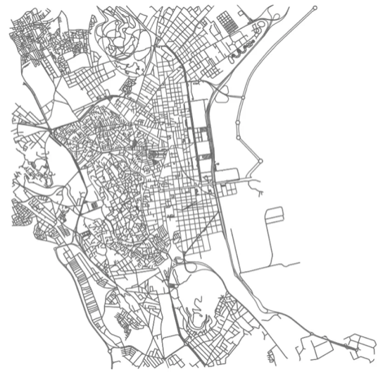 OSMnx detecting all streets in a city.

#### Requirements Matrix

|  |  |  |  |  |
| --- | --- | --- | --- | --- |
| **Req. #** | **Requirement** | **Description** | **Prototype #** | **Implemented** |
| 1 | Allowing user to choose a define location | * A defined location will help restrict the number of extracted images. After the requirement is satisfied, we will determine the search boundaries by either using a circle or collecting images between two spots. | 1 | Yes |
| 2 | Collecting street view Google images | * Obtaining and downloading a set of google street images to a specified folder. The search will execute to retrieve automated google images. | 1 | Yes  Currently 1 image |
| 3 | Removing unusable images | * Removing insignificant images will improve processing and add distance to our search. Only collecting images that show sidewalks and street asphalt view. Removing images such as the sky and buildings. | 1 | N |
| 4 | Creating user interface | * Create a website with an interactive google map as our main page. | 2 | N |
| 5 | Adding Maps Embed to web page | * An interactive map from Google Maps Embed API will be implemented on our website. The map will add a user-friendly interface. | 2 | N |
| 6 | Processing the batch of images | * Apply the Machine Learning algorithm to the images. | 2 | N |
| 7 | Storing and organizing data from meta data processing | * Once images are processed, metadata will be processed and will be applied in specific fields: Total litter, litter rating, regions where litter is highly impacted, and picture taken. A database will be implemented for organizing useful data. | 2 | N |

### 

### **Project Management**

#### **Gantt Chart**

### 

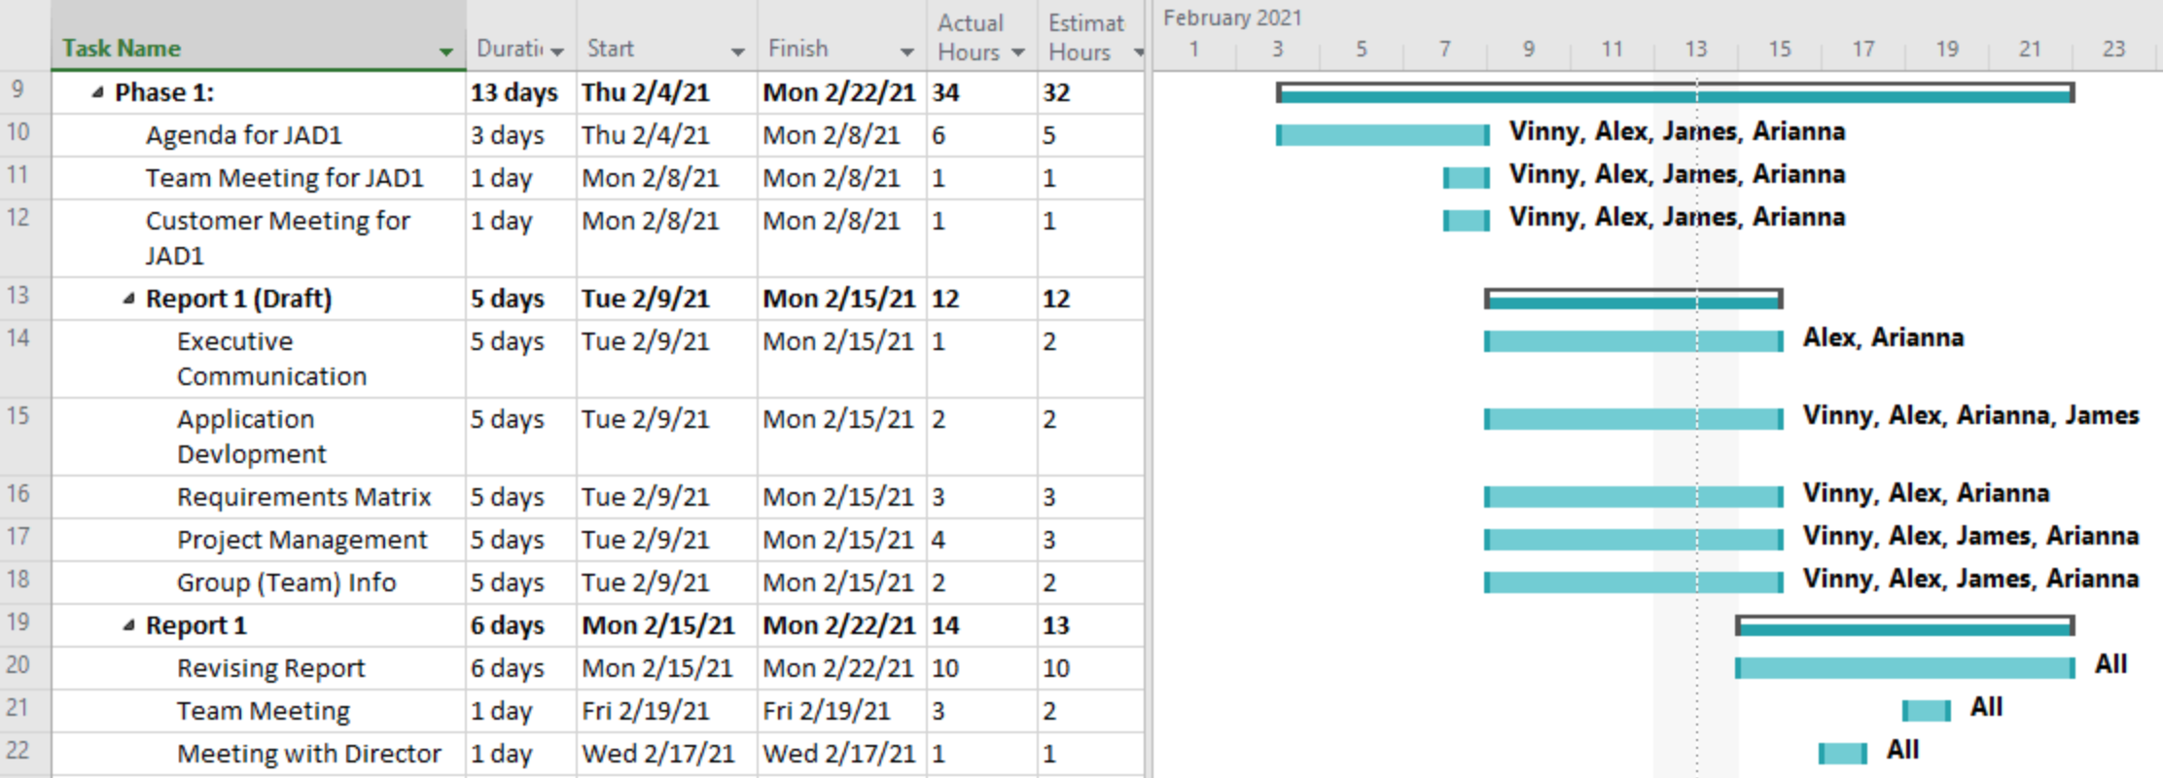

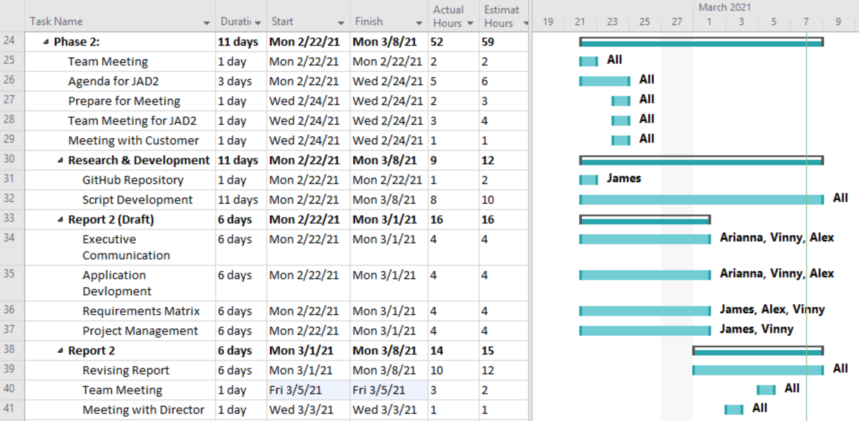

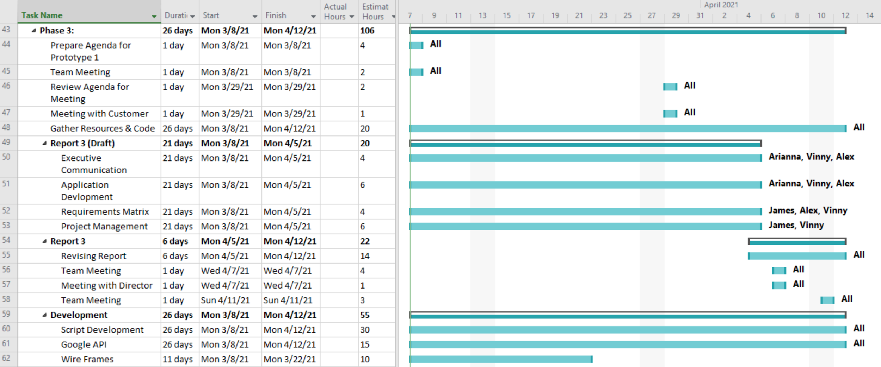

#### 

#### 

#### 

#### **Cost Tracking Chart**

We will assume an hourly rate of $25.00 per hour for this project. We assessed that this rate is appropriate for the project scope and requirements but is negotiable with the client if desired. Below is a chart outlining estimated and actual costs for each phase of the project as well as our total accumulated costs compared to our estimated costs. All values are represented in dollars.

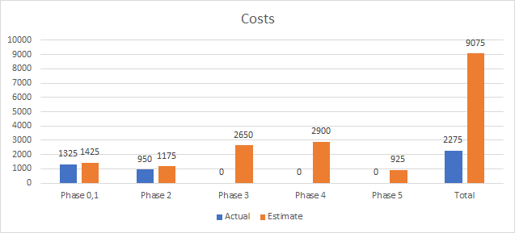

**Resources**

Our team will be supplying the following resources for this project:

* Our work and research into previous team projects and additional resources used.
* All images collected for the project.
* An updated document for each phase of the project.
* A final report detailing our process and updates throughout the project.

Our team will need to be supplied the following resources from the client:

* Reports from previous teams for reference
* Approval on our project solutions
* Future meeting availability

### **Team Information**

As a team, we expect to have all team members contribute knowledge, opinions, and time consistently to fulfill weekly goals throughout the life of the project. Team members will conduct themselves professionally, respectfully, and cordially among each other and with Dr. Schultz. Collaboration among all team members will play a key role in the team’s success.

|  |  |
| --- | --- |
|  | **Oscar Castellanos**  Project Leader  Cell: 760-693-6704  Email: Caste055@cougars.csusm.edu  **Experience**: Experience leading previous groups and managing a team! |
|  | **James Hanlon**  Project Manager  Cell: 760-330-1910  Email: Hanlo007@cougars.csusm.edu  **Experience**: Familiar with Google Maps and Street View but no experience implementing API’s. Very good communicator, have led students and children for many years with previous roles. Can resolve issues and conflicts if they arise, as well as identify the end result the customer desires. |
|  | **Arianna Camino**  Multimedia Programmer  Cell: 760-497-5890  Email: Camin003@cougars.csusm.edu  **Experience**: No previous experience with machine learning or Google Maps API, some experience with AWS and databases, plenty experience communicating and working with groups of all kinds. |
|  | **Alex Garcia**  Documentation & Training  Cell: 951-358-2990  Email: Garci825@cougars.csusm.edu  **Experience**: No experience or background in Google Map API, machine learning, or Python. Experience in collaborating with others in achieving the best possible outcome of any project or service. |
|  | **Vinny Vue**  Programmer/Database Administrator  Cell: 858-245-0618  Email: vue003@cougars.csusm.edu  **Experience**: No previous experience with Google Map API or machine learning. Familiar with programming languages and web design along with databases. As well as working and collaborating in a team environment. |

#### Team Resumes



 

 